Exercise #1:

- Create two text files in your home directory using vi editor.
  - Run vi from command line
  - Press i to start entering the text
  - Enter the text (a few lines)
  - Press Escape to use vi commands
  - Type :w filename and press Enter to save the file.
  - Type :wq and press Enter to leave the editor
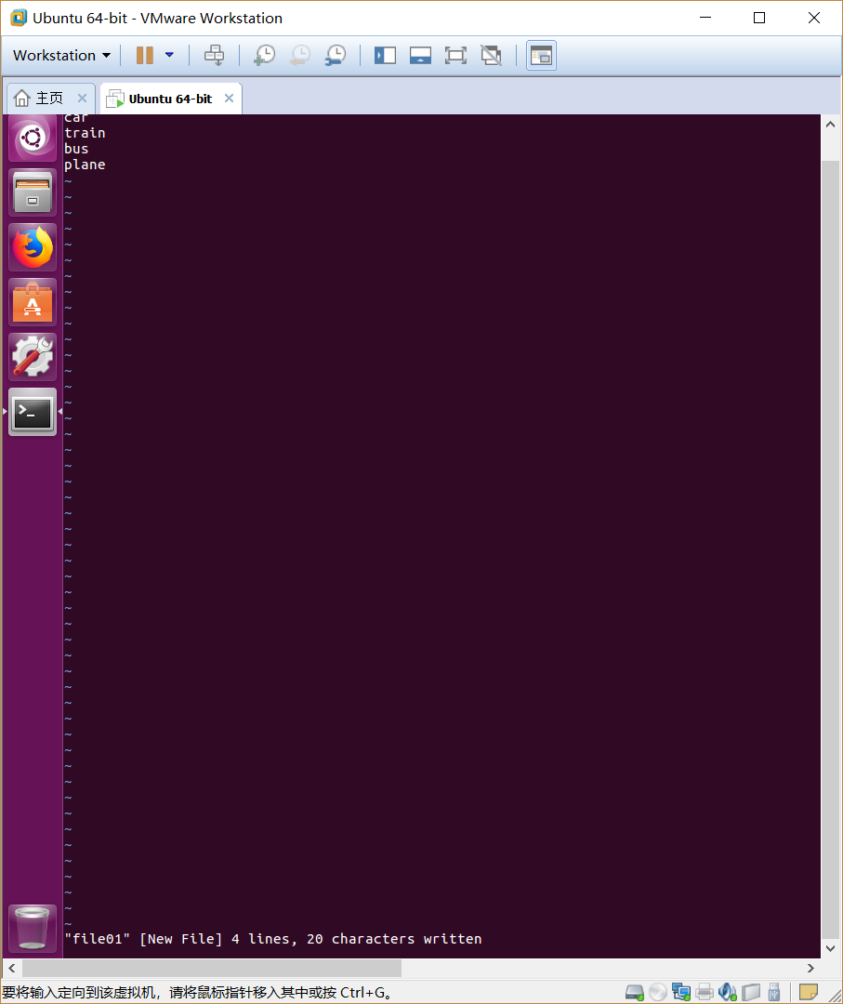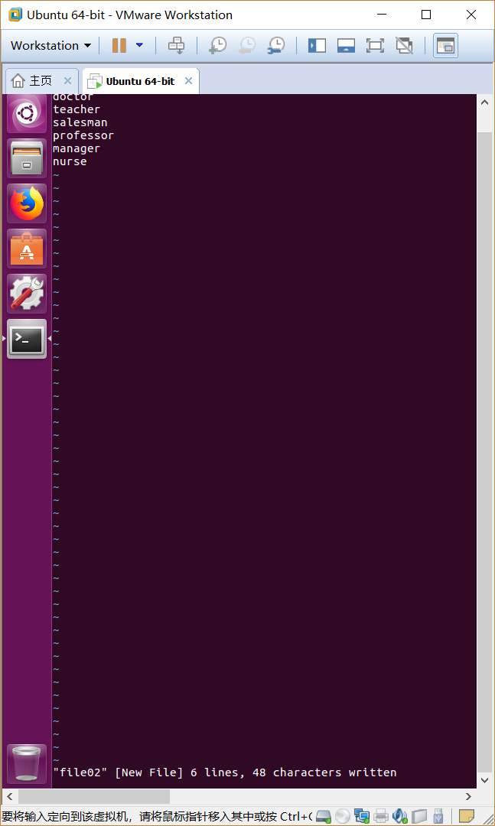
- Use ls command to display complete information about the above files
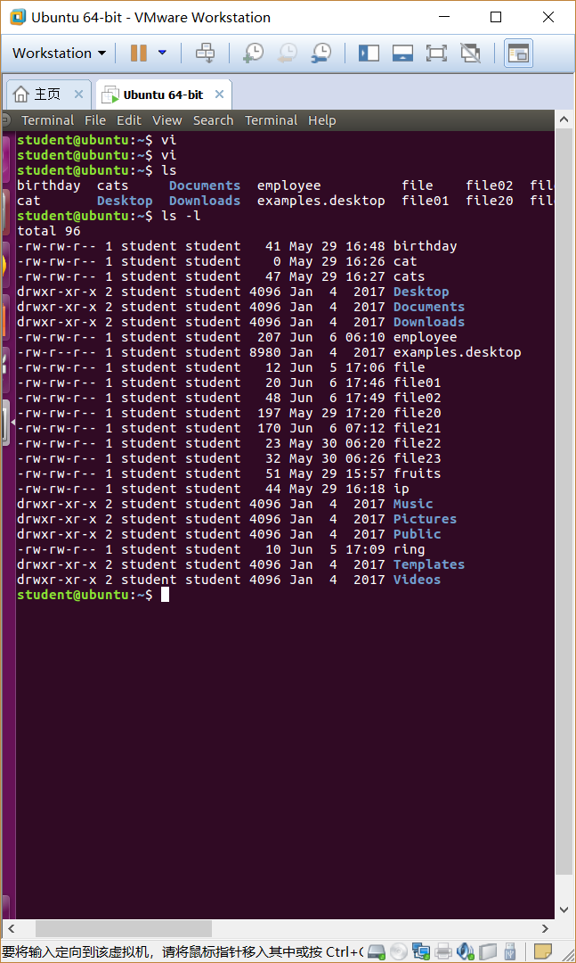

- Change the permissions for users to: r w –

- Change the permission for groups to: r w –

- Change the permission for others to: r w –

- Use again the ls command to display the updated information
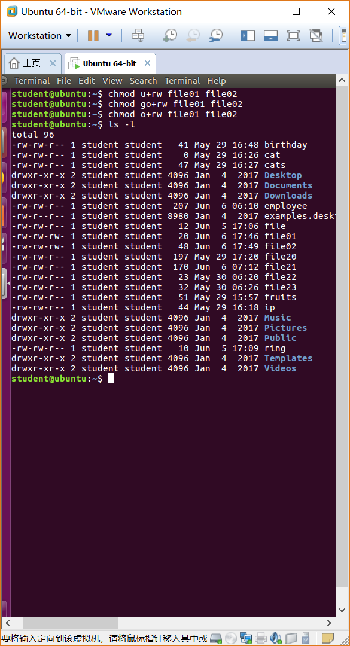

- List the groups you belong using: groups username

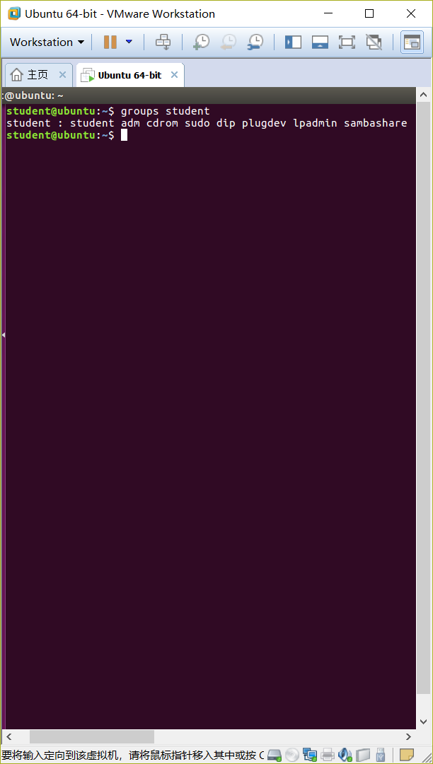

Exercise #2:

Original Perm | chmod arguments | Final Perm | Octal value
r w - r - - - - - | o+rw | r w - r - - r w - | 646
r w - r - - r - - | u-w go-r o-r | r - - - - - - - - | 400
r w x - - - - - - | u+rwx go+rwx o+rwx | r w x r w x r w x | 777
r w x r w - - w x | u-rwx go-rw o-wx | - - - - - - - - - | 000
- - - - - - - - - | u+r go+r o+r | r - - r - - r - - | 444
r - - r - - r - - | -w implies all | r - - r - - r - - | 444
r w - r w - r w - | -w implies all | r - - r - - r - - | 444
r w - r w - r w - | a-w | r - - r - - r - - | 444
- - - - - - - - - | u+w,g+rx,o+x | - w - r - w - - - x | 261
r w x r w x r w x | a=r | r - - r - - r - - | 444

Exercise #3:

- Create a directory dir-perm in your HOME directory and set permissions to
d r w x - - - - - - Fill in the command chmod _____ dir-perm
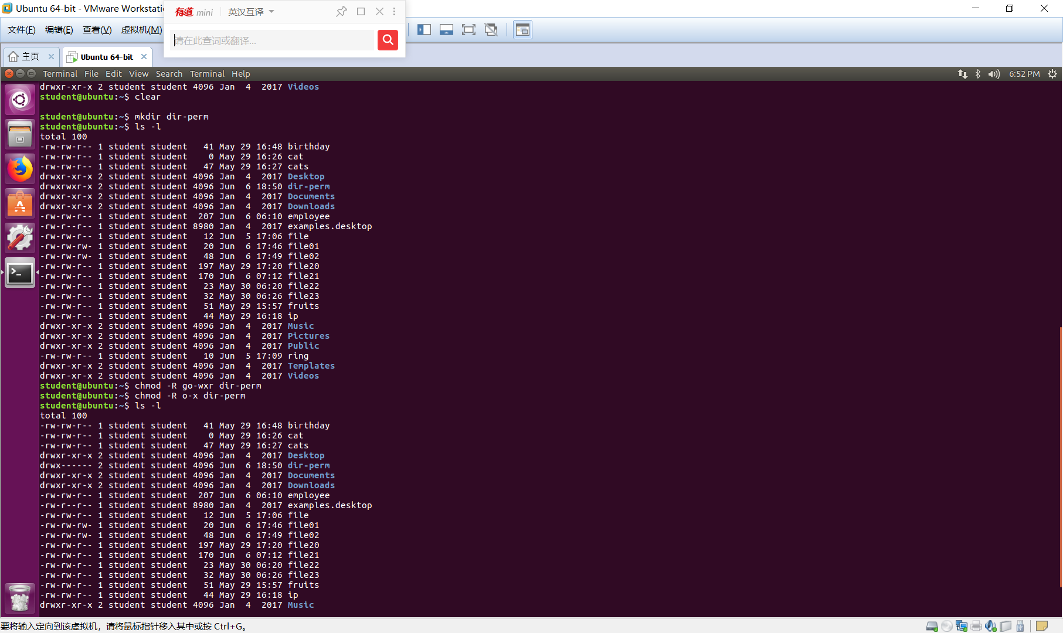

- Make dir-perm the cwd. How ________ cd dir-perm makes it the current working directory ___________________________

- Create a file in the dir-perm directory. How? _________________________
Call it file-perm
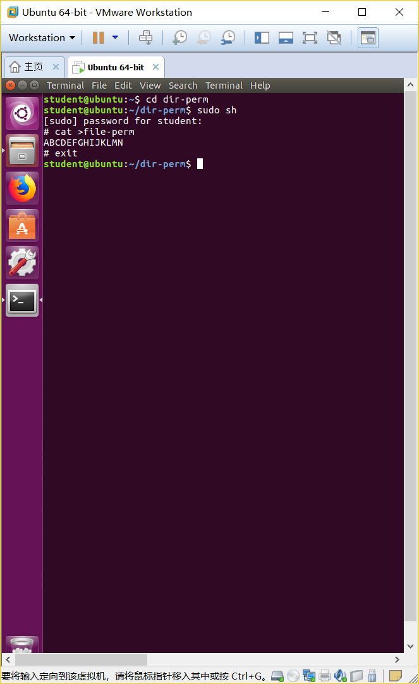

- Perform a “long” listing and give the permissions of the file created above.
Give the permissions. _____________________________
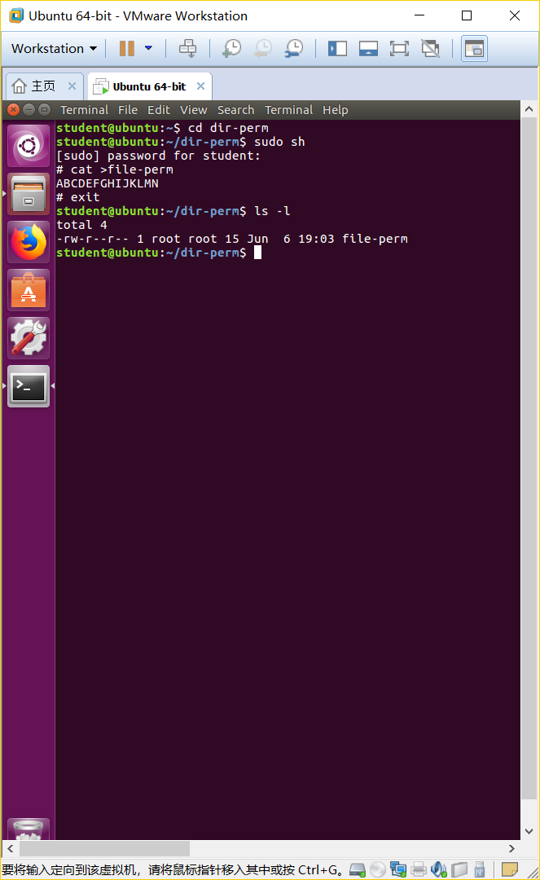

- Move back to the HOME directory. How? _____________________
- 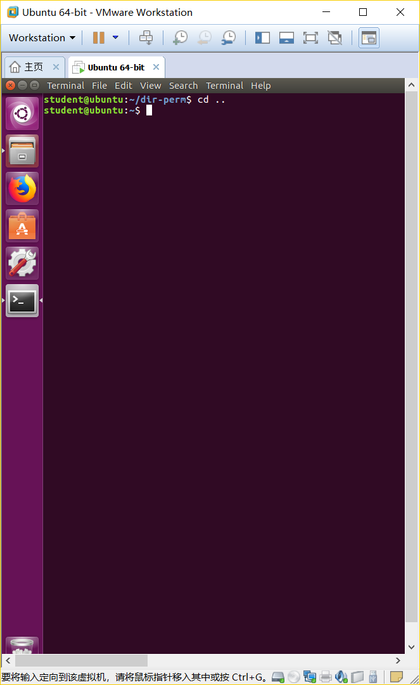

- Change the permissions to d r - x - - - - - -. How chmod __________

- 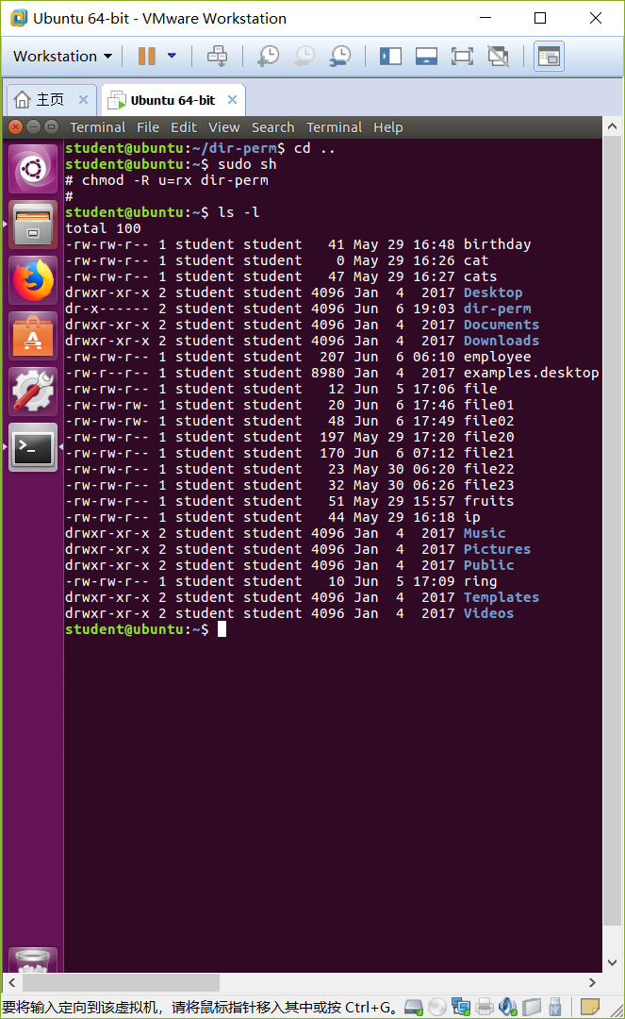

- Move to the dir-perm directory. How _________ cd dir-perm ____________________

- Create a second file in the directory (Use an editor) and try to save the file.
What happened?

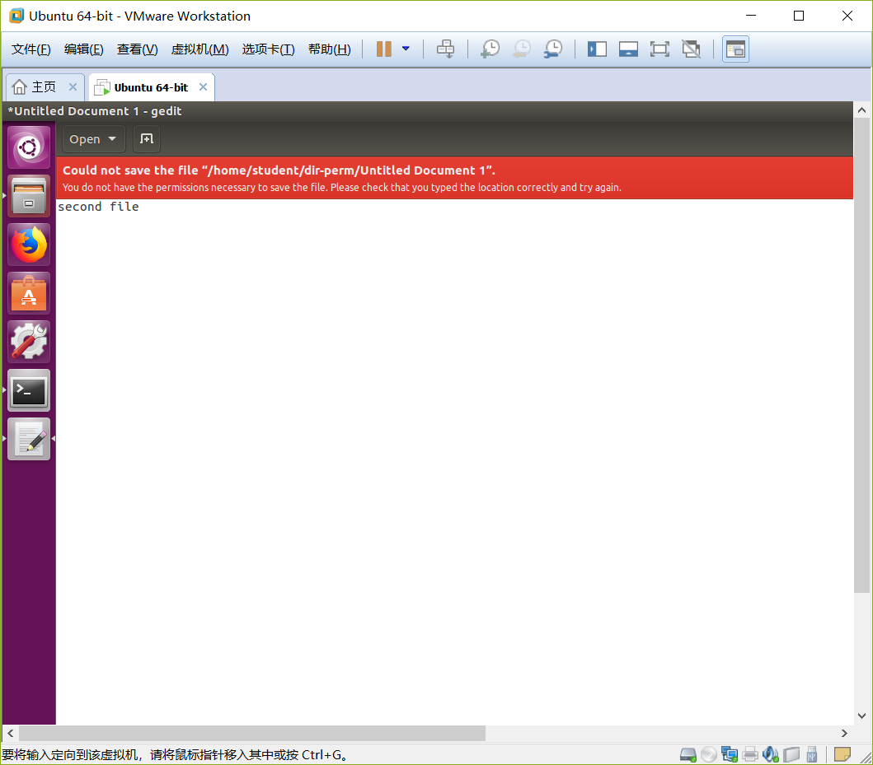

- Now edit the file-perm using an editor and save it.
What happened?

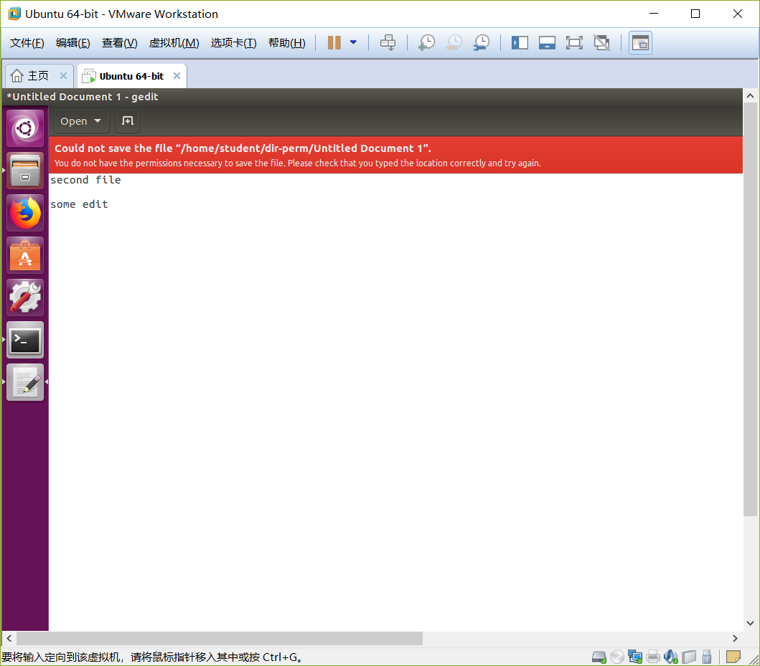

- Change the permissions so members of your group can access the dir-perm
directory, list the contents of the directory and read the file-perm file. Give the commands (steps) used here.
- Switch to HOME directory using cd ..
- Get into super user using sudo sh
- Use chmod -R go+r dir-perm. This should set the directory, and its contents permissions to read only. Then exit superuser using Ctrl+D or exit
- Now members of group can access dir-perm, list the contents, and read the file-perm file, but they can’t manipulate anything
